#### How to read this doc:

#### Assume I am the PM of Twitter Messages

#### Assume you are a stakeholder viewing this doc on 25th October

#### All numbers are hypothetical (I don’t have access to Twitter’s data)

#### Assume the functional requirements have been written keeping Mobile apps in mind and not web

#### Had originally planned this doc as a follow up to a Twitter Messages redesign exercise I did with Aristos group. Then realised I can share this with a wider audience considering multiple people have asked me in the past about how to write a Product spec doc

#### This is just a product spec. It does not include user flows

#### Will write separate doc

#### With wireframes (on how I would do the reactions feature)

#### On how to prioritise between features

#### My goal is to start from planning OKRs and come down to individual product specs :)

# Emoji Reactions on Twitter Messages

*This spec discusses more about (****WHY,******WHAT, WHEN)*** *needs to be built for showing reactions on Twitter messages. It does not discuss the technical implementation* ***(HOW)*** *for it. For technical implementation please check the Design, Backend and Frontend tech specs*

*Author: Manasjyoti Saloi, Fictional PM of Twitter Messages*

*Last updated: February 6th, 2020*

# Current Status: On Track, M1 ongoing

#### **Links:** [Pitch Doc](https://docs.google.com/document/d/1ez5NflYwy9DxhAXzg2AA2p0eMLVWg3QgxHatg3Td1zA/edit?usp=sharing) | [Backend Tech Spec](https://docs.google.com/document/d/1CB33dYpiK6JrgJl7_swlPUFz-Y-St8E9GnpuzzohdbY/edit?usp=sharing) | [Frontend Tech Spec](https://docs.google.com/document/d/1RvslTOIHBHknK54ftASaHcFEnK4ytueJ5_4jCjvDZkg/edit?usp=sharing) | Design Spec | QA Plan

## Table of Contents

How to read this doc: 1

Assume I am the PM of Twitter Messages 1

Assume you are a stakeholder viewing this doc on 25th October 1

All numbers are hypothetical (I don’t have access to Twitter’s data) 1

Assume the functional requirements have been written keeping Mobile apps in mind and not web 1

Links added to this doc take you nowhere. It is expected. It just means there will be separate docs for those 1

Had originally planned this doc as a follow up to a Twitter Messages redesign exercise I did with Aristos group. Then realised I can share this with a wider audience considering multiple people have asked me in the past about how to write a Product spec doc 1

This is just a product spec. It does not include user flows 1

Will write separate doc 1

With wireframes (on how I would do the reactions feature) 1

On how to prioritise between features 1

My goal is to start from planning OKRs and come down to individual product specs :) 1

**Emoji Reactions on Twitter Messages** **1**

**Current Status: On Track, M1 ongoing** **1**

Backend Tech Spec | Frontend Tech Spec | Design Spec 1

Table of Contents 1

What are emoji reactions? 3

Why build this feature? 3

Why build this feature over other features in our backlog? 4

Pre Launch Data & Research 4

Main User Stories 4

Goal of this feature 4

Success metrics 5

Potential metrics watch out / impact 5

DACI 6

**Product Requirements** **6**

**<User Flows come here>** **8**

**<How do we educate customers about this feature?>** **8**

Non Product Requirements 8

Out of scope for now 8

Configurability 8

**Roll out Plan** **9**

Detailed roll out plan with details on experiments we will be running 9

Post launch research plan comes here 9

Post launch impact analysis comes here 9

Open Questions 9

**Feature Development Checklist for M1** **10**

**MOMs** **11**

## What are emoji reactions?

It is a new feature we are proposing which let users react to a Message –– both text and media attachments with an emoji

## Why build this feature?

* **It is part of Twitter Messages Team’s OKRs**
  + **OKR** - O1 from Twitter Messages Team’s H2’19 OKRs: Close feature parity gaps with competition on key use cases
  + **KR** - Launch Emotion Reaction
* **Usage of Twitter Messages**
  + 150 million DAU of Twitter
  + 15 million daily unique users of Messages
  + ~10% of DAU send a Message
  + This makes Messages one of the most popular features of Twitter and something we should focus on [to be the best at](https://docs.google.com/document/d/1sUX-sm5qZ474PCQQUpvdi3lvvmWPluqHOyfXz3xKL2M/edit#)
* Recent report by our Data Science team showed a **strong correlation between usage of Twitter Messages with short term retention (STR)** (7 day)
  + New users who sent a direct message within the first 1 week had a 40% higher chance of short term retention than users who did not
    - [Detailed report here](https://docs.google.com/document/d/1sUX-sm5qZ474PCQQUpvdi3lvvmWPluqHOyfXz3xKL2M/edit#)
  + **Improving short term retention is one of the main OKRs for Twitter in H2’19**
* Over the last one month period
  + 10% of DAU of Messages have sent an emoji as a message reply
    - This implies that emoji reactions can often replace the need for follow-up messages or replies in Messages
  + 14% of all message replies sent during a day are emojis
    - Currently ~37 million messages being sent daily
  + **3 most commonly used emojis (Thumbs up, The face with tears of joy, The Red heart) count as 5% of all message replies**
* **Request from users**
  + **Survey findings**
    - We recently sent out a survey to 10 million power users of Messages (power users = those who have used direct message at least 10/ last 30 days, and sent 30 messages in that period)
      * Details on the survey sent and its findings can be found [here](https://docs.google.com/document/d/1sUX-sm5qZ474PCQQUpvdi3lvvmWPluqHOyfXz3xKL2M/edit#)
    - Ability to add emojis as a reaction counted as the 2nd most requested feature
  + **Focus Group Discussions (FGD)**
    - We did an FGD in our SF office
      * Details can be found here
    - The FGD report also mentioned emoji replies as a ‘must have’ new feature
  + **Zendesk Tickets**
    - [20% of tickets on Zendesk which are marked as Feature requests mentioned emoji reactions](https://docs.google.com/document/d/1sUX-sm5qZ474PCQQUpvdi3lvvmWPluqHOyfXz3xKL2M/edit#)
      * This included requests from
        + Play Store
        + Social Media requests
        + Support requests from Twitter app
* **Competition parity**
  + Facebook introduced the ability to react to DMs more than a year ago and our competitor intel team has mentioned that 1/4th of Facebook DM users in the last one month have used an emoji reaction

## Why build this feature over other features in our backlog?

[Roadmap for Twitter Messages](https://docs.google.com/document/d/1sUX-sm5qZ474PCQQUpvdi3lvvmWPluqHOyfXz3xKL2M/edit#), [Items in our backlog](https://docs.google.com/document/d/1sUX-sm5qZ474PCQQUpvdi3lvvmWPluqHOyfXz3xKL2M/edit#) and [Prioritisation sheet here](https://docs.google.com/document/d/1sUX-sm5qZ474PCQQUpvdi3lvvmWPluqHOyfXz3xKL2M/edit#)

## Pre Launch Data & Research

[Key Numbers for Twitter Messages](https://docs.google.com/document/d/1sUX-sm5qZ474PCQQUpvdi3lvvmWPluqHOyfXz3xKL2M/edit#)   
[Request from users: Survey findings](https://docs.google.com/document/d/1sUX-sm5qZ474PCQQUpvdi3lvvmWPluqHOyfXz3xKL2M/edit#)

[Request from users: FGD findings](https://docs.google.com/document/d/1sUX-sm5qZ474PCQQUpvdi3lvvmWPluqHOyfXz3xKL2M/edit#)

[Report on impact of Twitter Messages on STR](https://docs.google.com/document/d/1sUX-sm5qZ474PCQQUpvdi3lvvmWPluqHOyfXz3xKL2M/edit#)

[Feature requests on Zendesk Report](https://docs.google.com/document/d/1sUX-sm5qZ474PCQQUpvdi3lvvmWPluqHOyfXz3xKL2M/edit#)

[Competitive Intel Report](https://docs.google.com/document/d/1sUX-sm5qZ474PCQQUpvdi3lvvmWPluqHOyfXz3xKL2M/edit#)

## Main User Stories

* As a user, I would like to react with an emoji to a message sent to me
* As a user, I would like to inform the sender about my reaction
* As a user, I would like the ability to undo my reaction if needed
* As a user, I would like to express positive, neutral as well as negative emotions through this reaction feature

## Goals of this feature

* Make Messages the best in class messaging product by introducing highly requested features like emoji reactions
* Competition parity
* Improve STR of Twitter users by giving the best messaging experience possible

## Success metrics

* 5% of DAU of Messages should send a reaction
  + Half of DAU of Messages who have sent emoji as a message reply
* Reactions should be around 5% of messages sent daily
* Improve STR of new Twitter users by 10%

## Potential metrics watch out / impact

* Messages sent daily
  + 14% of all message replies sent during a day are emojis
  + 3 most commonly used emojis (Thumbs up, The face with tears of joy, The Red heart) count as 5% of all message replies
  + If we introduce emoji reactions #messages sent daily will be negatively impacted
  + Based on anecdotes during FGDs, users send emojis as reply when they have nothing more to say
  + Reaction is even more low friction and impersonal (arguably) and hence it might indicate to the recipient that the sender is no longer interested in the conversation. This is a hypothesis on why messages sent might do down further with introduction of reaction emojis
    - We will validate this through UTs and also data collected post launch
* Unique message senders
  + Daily average of 4 million users who have sent an emoji as a message reply
    - Out of these 4 million, ~100k users sent an emoji as the only message during the day
  + We either need to change the definition of message senders to include emoji reaction senders or accept that this number will go down
* Short Term Retention (STR) of Twitter new users
  + Usage of Messages feature has a positive impact on STR of Twitter new users
  + Building a better Messaging product should help in improving STR
    - We will test impact on STR by doing an AB test
    - Control will be new users without this new reactions feature
    - Experiment variant will be the segment of new users who have access to emoji reactions
    - [Detailed experiment plan can be found here](https://docs.google.com/document/d/1sUX-sm5qZ474PCQQUpvdi3lvvmWPluqHOyfXz3xKL2M/edit#)
* Usage of each emoji
  + For now we are going with 7 most commonly used emojis to describe a range of emotions (from positive to negative)
  + We will monitor the usage of each

## DACI

| **Decision** | **Driver** | **Approver** | **Contributors** | **Informed** |
| --- | --- | --- | --- | --- |
| We have decided to show only 7 emojis as of now. [Those emojis have been selected based on this framework](https://docs.google.com/document/d/1sUX-sm5qZ474PCQQUpvdi3lvvmWPluqHOyfXz3xKL2M/edit#) | Manasjyoti | Manasjyoti’s Boss  (Note: In some cases it can be Manasjyoti himself or some external stakeholder. Depends on who is the owner of this decision) | <Add relevant people who contributed to this decision here> | <Add relevant people who have been informed about this decision here> |
| <Add other important decisions taken here> | | | | |

# Product Requirements (The What)

| **Requirement** | **Priority** | **Phase/Milestone** | **Status** |
| --- | --- | --- | --- |
| Show Reaction button (heart and plus icon) next to the message when user hovers over the message on Mobile apps (Android and iOS) | Must Have | M1 | Done |
| React to a message by tapping the reaction button (heart and plus icon) and using the pop-up | Must Have | M1 | Done |
| React to a message by long pressing on the message and then tapping the reaction button | Must Have | M1 | Done |
| Show pop-up with 7 pre defined emojis   [Link to the emojis and why they were selected to M1 here](https://docs.google.com/document/d/1sUX-sm5qZ474PCQQUpvdi3lvvmWPluqHOyfXz3xKL2M/edit#) | Must Have | M1 | Done |
| On selecting emoji, give feedback to the sender by attaching emoji with the message | Must Have | M1 | Done |
| Show reaction attached with the message to the recipient | Must Have | M1 | Ongoing |
| Onboarding/ Discovery for this feature | Must Have | M1 | Yet to Start |
| Send notification to recipient about this reaction by adding +1 on the Notification counter on Messages | Should Have | M2 | Yet to Start |
| Remove/undo reaction by tapping on the emoji next to the message | Should Have | M2 | Yet to Start |
| Remove/undo reaction by tapping on the same emoji on the popup | Should Have | M2 | Yet to Start |
| Counter next to emoji reaction: Needed for group messages | Must have | M3 | Yet to Start |
| Send push notification to recipient when she gets a reaction | Should have | M3 | Yet to Start |

# User Flows (link to mocks)

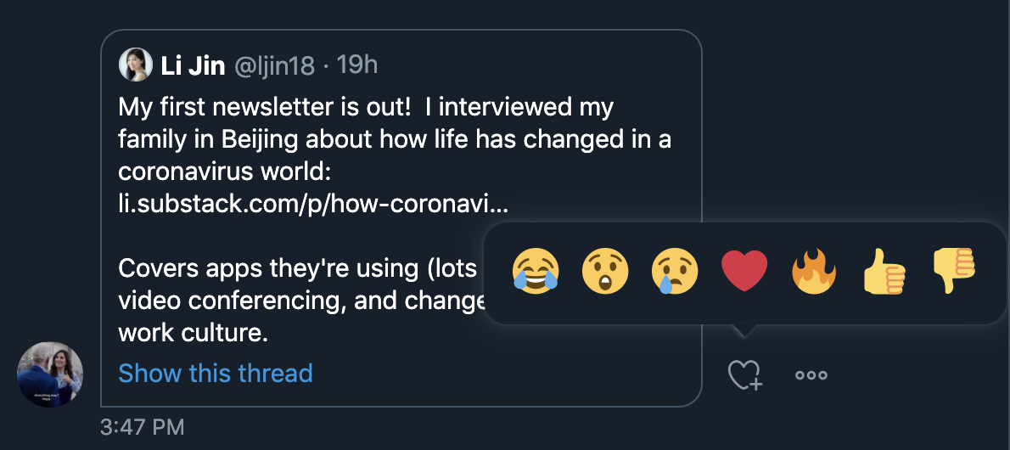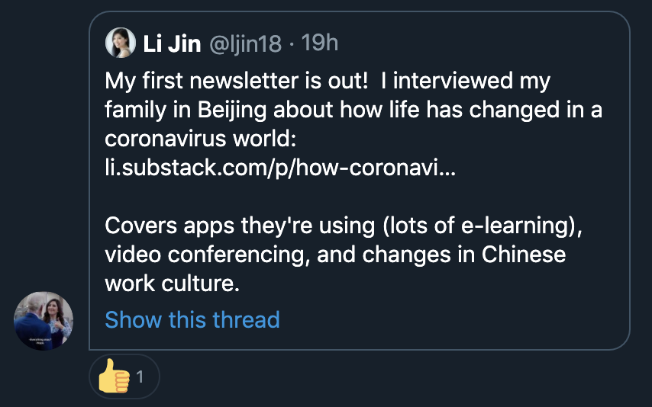

# 

# How do we educate customers about this feature?

* <Onboarding flow for this feature come here>
* <Different hooks through which we can expose this feature to the user or remind her about its existence come here?>

## Non-Product Requirements

| **Requirement** | **Priority** | **Phase/Milestone** | **PIC** | Status |
| --- | --- | --- | --- | --- |
| Marketing: Update Twitter Blog page on Messages | Must Have | Post M3 | Marketing | Yet to Start |
| Marketing: Announce feature to the world through our social media accounts | Must Have | Post M3 | Marketing | Yet to Start |
| Start PR for this feature | Must Have | Post M3 | PR | Yet to Start |

## Out of scope for now

* Reacting to a message in the Message requests section
* Reacting with emojis other than the predefined 7 emojis launching with M1

## Configurability

* This feature should be configurable based on
  + UserIds
  + Location
  + OS
  + Device
  + User segments

# Roll out Plan

* M1
  + Alpha on 10th Nov
  + Beta on 20th Nov provided there are no major bugs or concerns in Alpha
  + Will launch on Prod as an experiment on 25th Nov
  + [Experiment plan](https://docs.google.com/document/d/1sUX-sm5qZ474PCQQUpvdi3lvvmWPluqHOyfXz3xKL2M/edit#)
* M2
  + Alpha on 7th Dec
  + Beta on 14th Dec provided there are no major bugs or concerns in Alpha
  + Will launch on Prod after we have results on M1 experiment results
    - Rough timeline 20th Dec
* M3
  + Alpha on 5th Dec
  + Beta on 14th Jan provided there are no major bugs or concerns in Alpha
  + Prod on 24th Jan

## Detailed roll out plan with details on experiments we will be running

## Post launch research plan comes here

## Post launch impact analysis comes here

## Open Questions

* [Stakeholder from Marketing] How did we select the 7 emojis we are showing in M1
  + [Manasjyoti from Product]
    - We went through the most commonly used emojis
      * on social media in general
      * on twitter
      * on our competitors
    - Finally selection 7 to show all 3 types of emotions
      * Positive
      * Negative
      * Neutral
    - Link to the emojis and why they were selected to M1 here
* [Stakeholder from PR] Will we start shipping on Prod starting from M1? Should we wait till M3 for our PR drive around this feature?
  + [Manasjyoti from Product]
    - We will start doing experiments starting M1
    - PR can wait till all 3 Milestones are shipped on prod

# Feature Development Checklist for M1

| **Items** | **Status** | **Date** |
| --- | --- | --- |
| PM Spec v1 | Done | 15 August |
| Strong WHY | Yes. Mentioned in the Spec | 15 August |
| Kick Off with Design | Done | 20th August |
| Wireframes | Done | 4th September |
| Feedback on Wireframes  & PM - Designer alignment | Done | 8th September |
| Kick Off with Devs + QA + Design + Security Team + UX Writer | Done | 10th September |
| Backend Tech Spec | Done | 20th September |
| Frontend Tech Spec | Done | 27th September |
| PM - Dev Huddle | Done | 30th September |
| Spec Freeze (After iterations of scope cuts and creep based on Dev and Design discussions) | Done | 2nd October |
| Design Freeze (with High fidelity designs shared on Zeplin) | Done | 5th October |
| Roll Out Plan | Done | 10th October |
| --- Dev --- | Ongoing for M1 |  |
| QA (includes backward compatibility) | To be done (TBD) | To be done (TBD) |
| Copy freeze | TBD | TBD |
| Alerts for failure | TBD | TBD |
| Metrics on backend | TBD | TBD |
| Analytics events | TBD | TBD |
| Design Sign Off | TBD | TBD |
| Product Security Design Review | TBD | TBD |
| PM Sign Off | TBD | TBD |
| QA Sign Off | TBD | TBD |
| HOD Sign Off | TBD | TBD |
| Demo to Stakeholders | TBD | TBD |
| Ship on Prod | TBD | TBD |

# MOMs

<MOMs for meetings held & discussions on Slack relevant to this feature are added/ linked from here>

**Notes:**

* This is just a template. The sections might vary slightly based on how complex the feature is
* What matters most is that the WHY and the WHAT (scope vs non scope, milestones) is clear
* Competitive analysis, Hypothesis, and screenwise walkthrough with changes are missing in this spec, but might be important for some features
* Only high level project status update is shared at the top
* Main tasks of the project is captured in Asana (both PDG and non PDG)
* Dev stories are tracked on Jira and ideally should be part of the spec